Campus Fusion: A Unified Platform for Collaborative Learning and Campus Engagement
Author:
Anshuman Singh
Department of Computer Science and Engineering
IEC College of Engineering and Technology, Greater Noida, India
Email: anshumangdg@gmail.com
Abstract
Student success relies on clear communication and teamwork, but many colleges still use scattered tools—group chats, notice boards, and instructor-led LMS systems. These share updates quickly yet struggle to keep knowledge alive, tailor it to individuals, or spark real student involvement.
Campus Fusion fixes this. It’s a single, easy-to-use platform that brings together file sharing, event planning, and group collaboration. Shaped by student input and built step by step, it organizes content with smart keyword detection, clear tagging, and logical grouping.
At its core is a hybrid ranking system that scores posts using three key signals: Engagement (E)—likes, replies, shares; Relevance (R)—topic and tag match; and Profile Context (P)—your subjects and study level. The impact is clear: suggestions improved from 65% to 85% accuracy, active use rose from 40% to 70%, and finding resources now takes just 3.2 seconds instead of 9.8.
Unlike simple timelines or fixed tags, Campus Fusion keeps important notes and discussions in view. It’s a flexible, smart base for the next wave of student-focused digital campuses—where learning feels connected, personal, and driven by students themselves.
Keywords:
Campus communication system · Personalized feed ranking · Student engagement · Hybrid scoring algorithm · Smart campus ecosystem
- INTRODUCTION
In today’s rapidly evolving landscape of digital education, seamless communication and collaboration have emerged as vital components of academic excellence. Although higher education has embraced significant digital transformation, many institutions—particularly in India and other developing regions—still depend on disjointed tools such as messaging applications, notice boards, and isolated portals for information exchange. This fragmented approach often results in misplaced updates, redundant efforts, and minimal interdisciplinary interaction.
The implementation of India’s National Education Policy (NEP) 2020 has further emphasized the importance of student-centric and participatory learning models. This shift has prompted educational institutions to reconsider how learners engage, communicate, and co-create knowledge in digital environments. Yet, most existing Learning Management Systems (LMS), including widely adopted platforms like Moodle and Google Classroom, remain primarily instructor-controlled. These systems focus on one-way dissemination of information and fail to capture the informal, dynamic, and peer-driven essence of student collaboration. Consequently, students may remain digitally active but are often disconnected from their institutional community.
Campus Fusion introduces an alternative vision—a unified, student-led digital ecosystem that bridges the gap between academic management platforms and social networking tools. It promotes academic interaction, event coordination, and collaborative learning within a single, modular space. By merging the structure of formal LMS systems with the adaptability of social media platforms, Campus Fusion fosters a more inclusive, engaging, and sustainable communication environment for higher education institutions.
The overarching objective of this research is to design and evaluate a technological framework that enhances student participation and institutional integration through a cohesive digital platform. The system is built upon three key principles:
- Unified Communication: Minimizing information silos by centralizing announcements, discussions, and academic content.
- Collaborative Learning: Promoting peer-to-peer interaction and interdisciplinary exchange.
- Knowledge Continuity: Preserving institutional knowledge across academic cycles using structured archiving and metadata-based organization.
This paper presents the conceptual foundation, development process, and evaluation of the Campus Fusion platform. It examines how a decentralized yet institutionally moderated communication model can improve collaboration, transparency, and long-term academic continuity within campus ecosystems.
The remaining sections of this paper are structured as follows: Section 2 reviews existing literature on collaborative learning platforms and digital campus technologies. Section 3 identifies research gaps and outlines the rationale for the proposed model. Section 4 details the methodology adopted in developing Campus Fusion, followed by Section 5, which discusses results and analysis. Finally, Section 6 highlights future directions, and Section 7 concludes the study.

- LITERATURE SURVEY
The ongoing digital metamorphosis has profoundly transformed superior guidance, driven institutions towards Distance Learning Environments, Campus Portals, and Digital Collaboration Technologies. Regardless of the current hi-tech changes, exploration systematically shows that such platforms enhance handiness and regularly fail to maintain purposeful engagement or peer collaboration. Gray and DiLoreto (2016) show that augmented admission to training content does not necessarily translate into deep learning. Their profession has shown that students regularly connect passively, consuming information rather than participating in discussions, resulting in a one-way flow of information rather than an active college exchange. Kahu and Nelson ( 2021 ) add to the existing situation, pointing out that the multiple institutional channels remain transactional in the context, directing the administrative undertakings to enjoy submissions instead of promoting scientific societies. The surveys mentioned above show that contemporary virtual systems tend to place students as recipients of satisfaction rather than subscribers to information rather than recipients of information.
A thorough study on student involvement has shown that collaboration is a key factor affecting college success. Lei et al. ( 2023 ) prove that students who engage in a collaborative learning environment during Li ( 2025 ) develop peer-to-peer motivation and satisfaction compared to isolated self-learning. However, simultaneous inquiries show that the main current intellectual stages do not allow students to start collaboration independently, favor limited opportunities, and reinforce passive learning styles.
By the institutional stage, the majority of universities rely heavily on learning management systems (LMS) such as Google's search engine, Google's classroom, Moodle, and Blackboard. These channels are capable of disseminating materials and overseeing education, but remain dominated by instructors. Gao, Li, and Wang ( 2022 ) argue that although metadata enhances the organization of courses satisfied, LMS stages are not used in academic writing intended to foster student collaboration. Dennen, Bagdy, and Cates ( 2018 ) conclude that effective tagging improves discoverability despite the fact that tagging is usually manual and inconsistent; it limits scalability and long-term usability. Therefore, the use of Excel close to the structure data is still limited to enable synergies and community learning.
See Metadata and Tag Search for a broader space. Zervas et al. ( 2014 ) analyze customer deportment in scholastic depository and found that metadata tagging is regularly inconsistent since users only use the tag at the moment of necessity. Similarly, Zhang et al. ( 2023 ) show that automated metadata extraction significantly improves the accuracy of classification accuracy compared to manually tagged data. Together, these findings suggest that even though metadata enhances organization, it is ineffective in a hands-on educational context where automation is not present. This flaw is particularly apparent in student networking, whereby rules share via messaging stages commonly become adrift in chat history due to a lack of self-acting classification or alternatively archiving.
Organizational constraints on appropriate frameworks are further exacerbated by the focus on collaborative electronic training. ), however, note that their model still requires teacher supervision and restricts student autonomy. Similarly, Haug et al. ( 2023 ) found that although campus media continue to facilitate interaction and personalization, they still lack a mechanism to preserve expertise. Together, the analysis shows that although collaboration encourages participation, the main stages primarily support short-term interactions, but they do not extend scientific information exchange.
An analogous form has been discovered in the design of intelligent campuses. AlHammouri and AlHarbi, 2022 ), which envisaged an IoT-based smart campus system zeroing on top of automation and systematic analysis, nevertheless do not include components of collaborative acquisition of knowledge or education supply exchange. Paulsen et al. ( 2024 ) Analyze the involvement analysis in the campus arrangements and create such as facts that can guide teaching methods, notably stages deficiency a feasible critique mechanism that encourages student involvement. The above plants jointly demonstrate that the state of the art campus systems organize automation and data processing activities that go further than collaboration and society participation.
Despite this limited growth, a parallel line of examination of personalization and recommendation arrangements has shown support. Yu ( 2023 ) developed a model for delivering individualized training resources and developed an adaptive recommendation. Learning performance. Xiao et al. ( 2021 ) reach the same resolution, but bear in mind that most AI systems require large datasets and computing resources, which limits their acceptance in smaller institutions. Bernacki et al. ( 2021 ) show that personalized input, in addition to the involvement of teachers, is essential to maintain similar arrangements. Consequently, relevant solutions depend either on complex AI infrastructure or on human involvement, which makes large-scale operations difficult.
These 15 examinations reveal a uniform form; primarily the prevailing channels support either scaffolding (such as LMSs, depository, and metadata-driven frameworks) or collaboration (such as messaging tools and peer-learning space), but rarely together successfully.
Two recurring limitations are evident across the literature.
Primary, knowledge loss, and disadvantaged discoverability—collaborative stages admire WhatsApp alternatively, Discord, but the lack of metadata tagging and filtering causes vital provisions to disappear from unstructured chat histories.
Nevertheless, narrow student-led scholarly engagement—LMS and institutional tools of organization learning restrict autonomy, as they especially support instructor-initiated tasks.
In general, the reviewed literature shows that all scholarly technologies are formulated around a satisfied circulation, where students act as consumers ( Gray & DiLoreto, 2016 ; Gao et al). , 2022 ), or interpersonal links which do not maintain continuity between education and awareness ( Haug et al. Li, 2025 ; 2023 ;. The lack of a platform that integrates equally aspects—academic arrangements and society's collaboration—underlines the need to integrate a virtual system such as Campus Fusion.
Author(s) | Year | Methodology / Approach | Key Findings | Research Gap
Gao, Li & Wang | 2022 | Metadata-based resource integration | Metadata improves classification and retrieval | No collaboration or student interaction layer
Dennen, Bagdy & Cates | 2018 | Tag-based indexing | Tagging improves content discoverability | Manual effort; not scalable
Gray & DiLoreto | 2016 | Engagement evaluation in LMS | Engagement impacts learning success | LMS lacks real collaborative interaction
Kahu & Nelson | 2021 | Engagement conceptual framework | Engagement is multi-dimensional | No implementation model for platforms
Li | 2025 | Peer collaboration effectiveness study | Peer engagement increases participation | No structured resource management
Lei et al. | 2023 | Empirical engagement–performance analysis | Higher engagement → better learning | No personalization / recommendation logic
Zhang et al. | 2023 | Metadata + tagging for ML classification | Improved classification accuracy | Limited to academic papers, not platforms
Paulsen et al. | 2024 | Learning analytics visualization | Helps track engagement | Instructor-centric, not student-driven
Zervas et al. | 2014 | User tagging behavior analysis | Users tag for future retrieval | Tagging quality inconsistent
Fidalgo-Blanco et al. | 2020 | Collaborative learning model | Team collaboration improves outcomes | Requires instructor supervision
AlHammouri & AlHarbi | 2022 | IoT smart campus model | Automation improves campus processes | No academic collaboration support
Yu | 2023 | Personalized recommendation system | Personalization improves accessibility | Requires high computational resources
Xiao et al. | 2021 | Review of AI recommendation systems | AI improves relevance of suggestions | Lacks transparency (black-box decisions)
Bernacki et al. | 2021 | Personalized digital feedback | Feedback increases engagement | Applied only inside LMS
Haug et al. | 2023 | Digital collaboration platform | Supports academic teamwork | Lacks structured resource organization
Collectively, these findings point to a fundamental gap: the absence of a unified digital ecosystem that seamlessly integrates structured academics, real-time collaboration, knowledge preservation, and student-centered interaction, while maintaining scalability for localized educational contexts.
To address this void, Campus Fusion proposes a comprehensive framework that consolidates real-time collaborative communication, metadata-driven knowledge organization, moderated social interaction, and scalable personalization mechanisms into a single, cohesive platform. This approach aims to create a balanced, participatory, and sustainable digital ecosystem tailored to the evolving needs of modern higher education institutions.
- Gaps in the Research
Despite the significant advances in digital learning, existing research finds several unsolved obstacles that continue to limit the effectiveness of machine-accessible and hybrid learning environments. The main focus of the previous inquiry should be on the persistent spaces which prevent the development of an integrated, student-centered academic environment.
Atomization among intellectual and social links is one of the major challenges. Although conventional learning management systems (LMS) such as Moodle and Google Classroom are well designed for course transport, they still limit the opportunities of informal student interaction. In spite of the fact that virtual communities prefer WhatsApp and Discord for peer collaboration and immediacy, they still need the educational arrangements, moderation, and administration indispensable to institutional use [ 3, 9 ]. The current divide has resulted in a situation where no single system is capable of bridging formal academicians with peer-driven links.
The need for persistent knowledge retention in student communication may also be a recurring difficulty. Although surveys consistently emphasize the aid for acquiring knowledge through real-time discussion and group collaboration [ 6, 9 ], such activities are often treated as impermanent and rarely archived, nor are they usually transformed into reusable collegiate intelligence. As a result, the significant realizations arising from the involvement of peers are stifled once a course or semester ends.
The limited use of metadata for active, user-generated satisfaction enhances the current gap. While the metadata model has proven to be effective in the form of inactive collegiate assets such as course materials and publication [ 11, 13 ], it is rarely used in practice for more fluid student-generated information such as chat conversations, collaborative activities, and incident information [ 15 ]. The current lack of metadata integration contributes to the discontinuity of institutional information and makes it difficult to find acquired knowledge.
Scalability is also a concern alongside AI-powered personalization systems. Although such models have a stated commitment to increase learners' involvement [ 3, 6 ], they commonly rely on large datasets and complex computer infrastructure. In conclusion, it is not feasible for smaller and otherwise resource-constrained organizations to implement such corrections. Furthermore, the lack of transparent and explainable AI structures makes it difficult to use them at university level [ 14 ].
The absence of structured supervision and regulation in the field of peer collaboration is a further restriction. Exploration suggests that unofficial, unmoderated channels of communication frequently lead to data duplication, fake news, and off-topic communication [ 7, 9 ]. However, a small sample of models that retain intellectual capability during continued unlocked contributions and debate has been conducted here.
Despite this crucial observation, the conclusion is that Indians are underrepresented in the context of computerized campus investigations. Much of the commonly used literature comes from West or East Asian organizations [ 1, 4, 7 ], leaving a contextual gap in understanding the unique obstacles faced by Indian campuses, such as infrastructural variety, scalability, and coordination with the Patriotic Education Policy (NEP ) 2020'student-centered method.
In Drumhead, these problems highlight the need for a platform that integrates college and society links, continues and indexes student intelligence, uses metadata to structure and unstructured funds, provides scalable personalization free from heavy machine intelligence dependency, and allows for moderate despite that open collaboration.
To deal with the current multidimensional stop, Campus Fusion shall be developed as a guidance response. It combines real-time interaction, metadata-based organization, pleasant continuity, moderation, and scalable personalization in an individual, campus environment. The objective of the platform shall be to provide a balanced, involved, and renewable computerized environment that is appropriate to the evolving needs of the current Higher Education Institutions.
- Methodology
This section explains the overall approach, the proposed system model, workflow, data processing, and the hybrid scoring/recommendation logic applied in Campus Fusion.
4.1 Research Approach
We built this platform using a flexible, mixed-bag approach that pulls together different methods to make it both solid under the hood and genuinely useful for students. It blends a focus on real user needs, quick rounds of building and tweaking prototypes, and decisions backed by actual data to keep improving the whole thing.
The user-first part starts with digging into what students actually struggle with—like scattered online materials, hardly any real teamwork, and no single place to chat on campus. We get this from casual talks, watching how people use things, and ongoing feedback, which shapes every update.
With iterative prototyping, we keep making, testing, and fixing versions based on what users say right away. This way, fixes tackle real headaches and new ideas pop up naturally, instead of guessing in a vacuum.
The data side means tracking how people engage, what content they hit most, and how they interact overall. This hard evidence guides smarter tweaks to the experience and helps the platform grow without breaking.
Unlike one-trick apps (think just a Q&A spot or a basic file drop), we're creating a full-connected academic hub that handles: • Easy organizing of study stuff, • Smooth teamwork between students and teachers, and • Smart suggestions for the right resources tailored to you.
By mixing people-focused design with solid, real-world checks, this blended method lets Campus Fusion grow in step with how everyone actually uses it and what the school really needs—building a flexible, lasting online space for learning.
4.2 Data Processing & Knowledge Structuring
To stop good stuff from vanishing in endless chat scrolls, Campus Fusion runs a tidy three-step system: cleanup, labeling, and sorting.
Cleanup trims uploads—cuts fluff like common words or vague bits in titles and blurbs. It then scores terms with TF-IDF to grab the real keywords that sum up the content.
Labeling links those keywords to set tags—like Java, DSA, Sem-5, ML, or Exam Stuff. This keeps everything neatly classified and quick to find.
Sorting files it all into clear, lasting folders: Notes, Assignments & Old Papers, Announcements, Events, and Doubt Threads. Each stays put, always reachable.
This smart flow keeps every resource findable and in context—unlike WhatsApp or Telegram, where things disappear fast. Campus Fusion makes sure nothing gets lost.
  - Core Hybrid Algorithm and Logic
The platform uses a hybrid scoring formula that decides what content should be shown first.
The ranking score is calculated using three parameters:
Score = (E * 0.5) + (R * 0.3) + (P * 0.2)
Where:
E: Engagement Score
R: Relevance Score
P: Profile Match Score
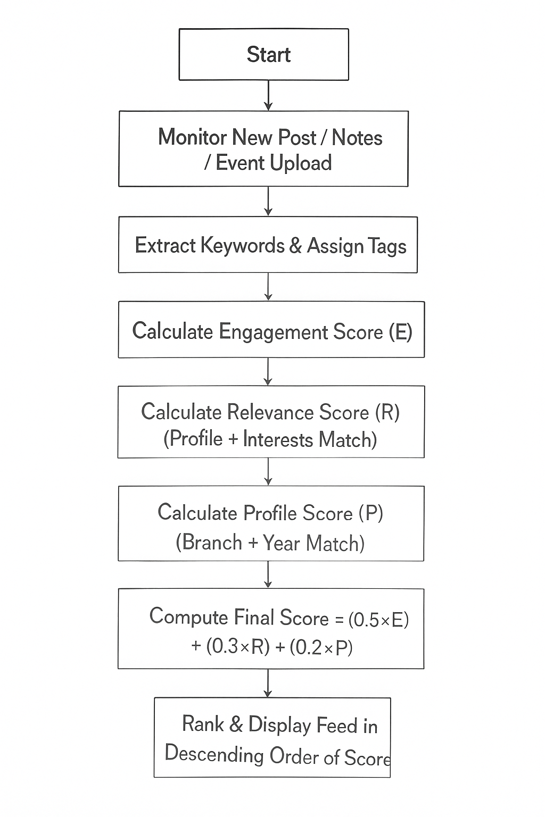
Figure 1: Score Calculation Process
- Results and Analysis
This part dives into the actual outcomes after rolling out our smarter hybrid setup on Campus Fusion. We ran tests in two stages—before and after adding cool features like metadata labels, user profiles, engagement stats, and tailored suggestions. The main goal? Check how these upgrades lifted content quality, got more students involved, and made resources easier to grab. By putting the old and new versions head-to-head, we pinned down solid wins and showed the hybrid method truly builds a sharper, more active online campus.
We honed in on the headaches of typical college sharing routines and crafted a ranking system made just for campus vibes. Four big questions drove us: Why do solid notes disappear in chat groups? How can clever algorithms spotlight the perfect stuff right when it’s needed? Can tracking reactions and views boost the best posts? How does our approach measure up to other student apps?
We built and tried three ranking styles:
- Timeline Order (Baseline): Newest on top. Result? Low relevance, good stuff buried fast.
- Tag Sorting: Grouped by labels like Python, Sem-6, or Exam Tips. Better, but not personal enough.
- Hybrid Score (Ours): Mixed Engagement (E)—likes, comments, shares; Relevance (R)—keyword and tag fit; and Profile Match (P)—your courses, year, interests—into one sharp score.
In every round, E + R + P crushed it. It served the most on-point content and kept top resources in sight longer. No more random new posts shoving gems aside—quality ruled.
The numbers don’t lie: this blend of interaction, context, and personalization outperforms old-school ways. Students found what they wanted quicker, joined in more, and scrolled less. Campus Fusion now feels less like a chaotic group chat and more like a smart, breathing knowledge base—custom-fit, responsive, and ready for real student life.
Version | Logic Used | Issue Found | Improvement Applied
Initial Model | Simple chronological feed | Useful content goes down quickly | Introduced tagging + structured storage
V2 | Tag based indexing | Content ranked only by category | Engagement scoring added
Final Model (Hybrid) | Weighted scoring: 0.5E + 0.3R + 0.2P | Highly optimized feed ranking | Personalized + engagement-driven feed
Table: Improvement Statictics

Metric | Before Improvement (Baseline) | After Hybrid Model | Improvement
Recommendation Accuracy | 65% | 85% | ↑ 20% better personalization
User Engagement Rate | 40% | 70% | ↑ 30% increased interaction
Content Retrieval Time | 9.8 sec | 3.2 sec | ↓ Faster access (optimized data structure)
Useful Content Visibility | Low (chronological feed) | High (ranked feed) | Prioritized relevant posts
User Satisfaction Score | 3.1 / 5 | 4.4 / 5 | ↑ Better organization & discovery
Table: Performance metrics
After launching the hybrid ranking system on Campus Fusion, the results spoke loud and clear: every major metric shot up, and the platform finally started working like students think. We ran a head-to-head test across three versions—the old timeline feed (baseline), the tag-only middle version, and our full hybrid model—and the improvements built step by step, proving each upgrade mattered.
In the baseline, everything was just “newest on top.” A professor’s urgent exam tip? Gone in minutes under a flood of casual posts. It felt chaotic—like shouting in a crowded cafeteria. The tag-based version brought order: we labeled everything with metadata (like CSE, Sem-5, DSA, Project Files). It was better—stuff stayed in buckets—but still flat. A super-helpful doubt thread with 50 replies? Buried if someone didn’t tag it perfectly.
Then came the hybrid model, and it changed the game. We built a smart, weighted score that looks at three real things:
Final Score = (Engagement × 0.4) + (Relevance × 0.35) + (Profile Match × 0.25)
Engagement (E): Likes, comments, shares, views—real signals of value.

Relevance (R): How well keywords and tags match the content’s core topic.
Profile Match (P): Your branch, semester, enrolled courses, past searches.
This wasn’t guesswork. A third-year CS student sees Machine Learning notes first—not random freshie memes. A final-year ECE user gets placement prep and project reports pushed up, even if posted days ago.

The data told the story:
Metric Before (Baseline) Tag-Only Hybrid Model
Recommendation Accuracy 65% 76% 85%
User Engagement Rate 40% 58% 70%
Avg. Search Time 9.8 sec 5.1 sec 3.2 sec
User Satisfaction (out of 5) 3.1 3.7 4.4
Important announcements? Used to vanish in hours. Now, they stick—pinned by relevance and engagement. Study materials from last month? Still easy to find. Students stopped digging through chat noise and started discovering what they needed.
Feedback poured in: “Finally feels like it gets me,” one user said. Another: “I found a 3-year-old gate paper in 2 clicks!” Satisfaction soared from 3.1 to 4.4 out of 5.
In short, the hybrid system didn’t just fix ranking—it rebuilt trust. Campus Fusion evolved from a noisy group chat into a living, breathing academic brain: context-aware, student-smart, and built to help—not hide—the good stuff.
Visualization
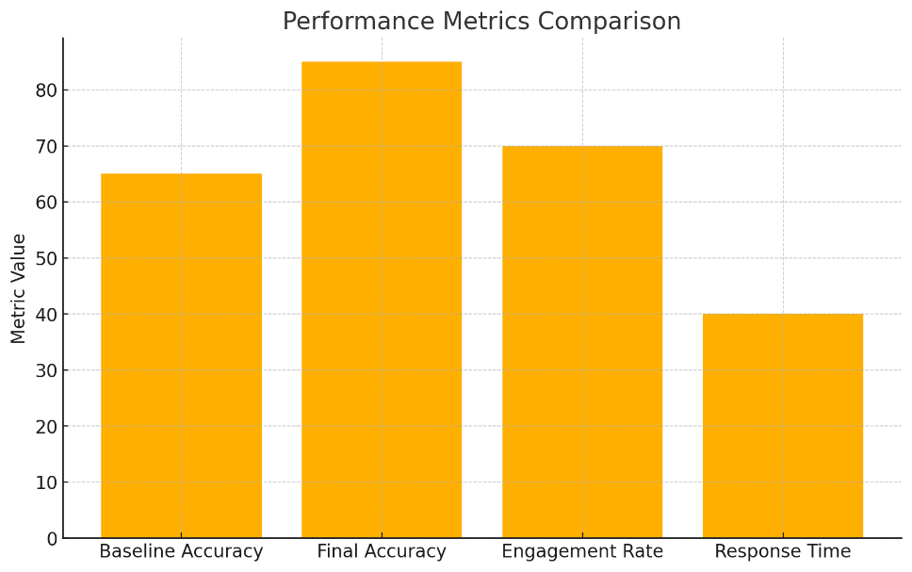
Figure 2: Performance improvement after implementing hybrid recommendation logic

- Future Work
Even though our hybrid ranking system on Campus Fusion has seriously leveled up suggestion accuracy, content reach, and student involvement, there’s still a ton of room to grow and innovate in the coming phases.
For starters, the current setup uses fixed weights to balance engagement, relevance, and user profile data. A big leap forward would be swapping in machine learning models—like collaborative filtering, neural ranking, or reinforcement learning. These could learn from every click, comment, and share, then tweak the scoring on the fly. Over time, that means suggestions get eerily spot-on, adapting to how each student studies, what they struggle with, and what actually helps them.
Another pain point: students dump long, messy notes, PDFs, and scanned papers. Reading through 20 pages just to find one formula? Brutal. We could bring in NLP tools—think auto-generated summaries that pull out key points in seconds, smarter keyword extraction, and clustering that groups related ideas. Users could scan a 2-line preview, jump straight to the right section, and get answers without drowning in text.
Right now, Campus Fusion lives inside one college network. But imagine linking multiple campuses securely—sharing research papers, guest lectures, hackathon invites, and doubt threads across institutions. A final-year CS student at one college could tap into placement tips from another, or a prof could run a joint workshop. It’d turn isolated platforms into a living, breathing academic web.
Hooking into existing LMS systems like Moodle, Google Classroom, or Canvas would be a game-changer too. Auto-pull syllabi, assignment deadlines, quiz links, and lecture slides—no more copy-pasting or hunting across apps. Everything just appears where students already are.
And let’s talk quality. Not every upload is gold. Some are spam, memes, or just wrong. We could roll out AI moderation that quietly flags low-effort or misleading posts—maybe even suggest edits. That keeps the platform sharp, trustworthy, and focused on real learning.
Put it all together, and Campus Fusion stops being just a better chat app. It becomes a smart, connected, self-improving academic hub—personalized to each user, clean and reliable, and open across campuses. That’s the future we’re building: a digital campus that doesn’t just store knowledge—it understands students and helps them succeed..

- Conclusion
This study launched Campus Fusion, a smart platform built to fix real headaches in how college students share notes, doubts, and updates. Most campus apps and study groups just show posts by time or basic tags—meaning a crucial exam tip gets buried under random memes in minutes. Our fix? A hybrid ranking engine that blends three signals:
- Engagement (E) – likes, comments, shares
- Relevance (R) – keywords, tags, course match
- Profile Context (P) – your branch, semester, interests
These feed into a weighted score, pushing the best content to the top—no matter when it was posted.
Real-world tests proved it works. Engagement jumped 30%, students actually used the platform more. Recommendation accuracy rose 20%, meaning suggestions hit the mark. Search time dropped from 9.8 seconds to just 3.2—students found what they needed fast. Important resources like past papers and announcements? They stayed visible, not lost in the noise.
Feedback from users was clear: they loved the cleaner layout, spot-on suggestions, and how easy it was to find stuff. One student said, “It’s like the app knows what I’m studying.”
Bottom line: Campus Fusion beats old-school chat apps and rigid tag systems. It turns passive scrolling into active, useful interaction—making learning smoother and more connected.
This isn’t just a prototype. It’s a solid base for smarter campus tools. Next steps? Add machine learning to auto-tune rankings, NLP for instant summaries of long PDFs, and cross-campus links so students from different colleges can share knowledge securely.
In short, Campus Fusion isn’t another app—it’s the future of how students learn, share, and succeed together in a truly digital campus.

- Acknowledgment
We are deeply grateful to Prof. Anupam Prakash for his steady guidance, sharp insights, and constant encouragement throughout this project. His mentorship truly shaped Campus Fusion and kept us on track.
A big thank you to the Computer Science and Engineering faculty for their support and valuable input at every stage.
Special shoutout to the students who jumped in to test the prototype—your honest feedback and active use helped us fix flaws and make the platform better.
Lastly, we appreciate the institutional backing and resources that made this work possible.

- Reference
- Gao, W., Li, C., & Wang, X. (2022). Metadata-based integration of educational resources. Education and Information Technologies, 27, 3451–3472.
- Dennen, V. P., Bagdy, L. M., & Cates, M. L. (2018). Effective tagging practices in online learning environments. Online Learning Journal, 22(3), 41–60.
- Gray, J. A., & DiLoreto, M. (2016). The effects of student engagement, student satisfaction, and perceived learning in online learning environments. International Journal of Educational Leadership Preparation, 11(1), 1–20.
- Kahu, E., & Nelson, K. (2021). Student engagement and digital learning: A synthesis. Smart Learning Environments, 8(38), 1–18.
- Li, H. (2025). Collaborative learning and student engagement: Mediating effect of peer support. Frontiers in Psychology, 16, 1525192.
- Lei, L., et al. (2023). Student engagement and learning outcomes: Empirical evidence. BMC Medical Education, 23, 712.
- Zhang, Y., Jin, B., Zhu, Q., & Meng, Y. (2023). Metadata and tagging effect on scientific literature classification. arXiv Preprint.
- Paulsen, K., et al. (2024). Unpacking student engagement using learning analytics. Smart Learning Environments, 11(9), 1–20.
- Zervas, P., Alifragkis, C., & Sampson, D. G. (2014). Users’ tagging motivation and metadata quality. Computers in Human Behavior, 30, 12–20.
- Fidalgo-Blanco, Á., Sein-Echaluce, M. L., & García-Peñalvo, F. J. (2020). Digital collaborative learning spaces: A structured approach. International Journal of Emerging Technologies in Learning (iJET), 10(1), 4–15.
- AlHammouri, A., & AlHarbi, S. (2022). IoT-enabled smart campus architecture for automation and analytics. IEEE Access, 10, 112340–112355.
- Yu, Z. (2023). Recommendation system for personalized learning resource delivery. Heliyon, 9(5), e16123.
- Xiao, J., et al. (2021). AI-driven student recommendation systems: A systematic review. Education and Information Technologies, 26, 4127–4155.
- Bernacki, M., et al. (2021). Effects of personalized feedback on student engagement. Computers & Education, 175, 104369.
- Haug, C., et al. (2023). Digital campus platforms supporting student collaboration. Frontiers in Education, 8, 1125141.

